НАЦІОНАЛЬНИЙ ТЕХНІЧНИЙ УНІВЕРСИТЕТ УКРАЇНИ
«КИЇВСЬКИЙ ПОЛІТЕХНІЧНИЙ ІНСТИТУТ»
ФАКУЛЬТЕТ ІНФОРМАТИКИ І ОБЧИСЛЮВАЛЬНОЇ ТЕХНІКИ
КАФЕДРА ОБЧИСЛЮВАЛЬНОЇ ТЕХНІКИ

Лабораторна робота №5
з дисципліни «Архітектура комп’ютерів 2»

Виконав:
студент 3 курсу
групи ІО-81
Павловець О. В.

Перевірив:
Каплунов А. В.

Київ 2020 р.
BASIC
Лістинг
/*
* Copyright (c) 2017, GlobalLogic Ukraine LLC
* All rights reserved.
*
* Redistribution and use in source and binary forms, with or without
* modification, are permitted provided that the following conditions are met:
* 1. Redistributions of source code must retain the above copyright
* notice, this list of conditions and the following disclaimer.
* 2. Redistributions in binary form must reproduce the above copyright
* notice, this list of conditions and the following disclaimer in the
* documentation and/or other materials provided with the distribution.
* 3. All advertising materials mentioning features or use of this software
* must display the following acknowledgement:
* This product includes software developed by the GlobalLogic.
* 4. Neither the name of the GlobalLogic nor the
* names of its contributors may be used to endorse or promote products
* derived from this software without specific prior written permission.
*
* THIS SOFTWARE IS PROVIDED BY GLOBALLOGIC UKRAINE LLC ``AS IS`` AND ANY
* EXPRESS OR IMPLIED WARRANTIES, INCLUDING, BUT NOT LIMITED TO, THE IMPLIED
* WARRANTIES OF MERCHANTABILITY AND FITNESS FOR A PARTICULAR PURPOSE ARE
* DISCLAIMED. IN NO EVENT SHALL GLOBALLOGIC UKRAINE LLC BE LIABLE FOR ANY
* DIRECT, INDIRECT, INCIDENTAL, SPECIAL, EXEMPLARY, OR CONSEQUENTIAL DAMAGES
* (INCLUDING, BUT NOT LIMITED TO, PROCUREMENT OF SUBSTITUTE GOODS OR SERVICES;
* LOSS OF USE, DATA, OR PROFITS; OR BUSINESS INTERRUPTION) HOWEVER CAUSED AND
* ON ANY THEORY OF LIABILITY, WHETHER IN CONTRACT, STRICT LIABILITY, OR TORT
* (INCLUDING NEGLIGENCE OR OTHERWISE) ARISING IN ANY WAY OUT OF THE USE OF THIS
* SOFTWARE, EVEN IF ADVISED OF THE POSSIBILITY OF SUCH DAMAGE.
*/

#include <linux/init.h>
#include <linux/module.h>
#include <linux/moduleparam.h>
#include <linux/printk.h>

#include <linux/types.h>

MODULE_AUTHOR("Serhii Popovych <serhii.popovych@globallogic.com>");
MODULE_DESCRIPTION("Hello, world in Linux Kernel Training");
MODULE_LICENSE("Dual BSD/GPL");

static uint iterations = 1;
module_param(iterations,uint,0);
MODULE_PARM_DESC(iterations, "Number of iterations of printing hello world");

static int __init initter(void)
{
uint i = 0;

printk(KERN_INFO "iterations: %d\n", iterations);

if(iterations == 0) {
printk(KERN_WARNING "WARNING, iterations is 0");
}else if(iterations >=5 && iterations <= 10) {
printk(KERN_WARNING "WARNING, iterations is >=5 and <=10");
} else if(iterations > 10) {
printk(KERN_ERR "ERROR, iterations is >10");
return -EINVAL;
}

for(i = 0; i < iterations; i++){
printk(KERN_INFO "Hello, world!\n");
}
return 0;
}

static void __exit exitter(void)
{
/* Do nothing here right now */
}

module_init(initter);
module_exit(exitter);

Скріншоти

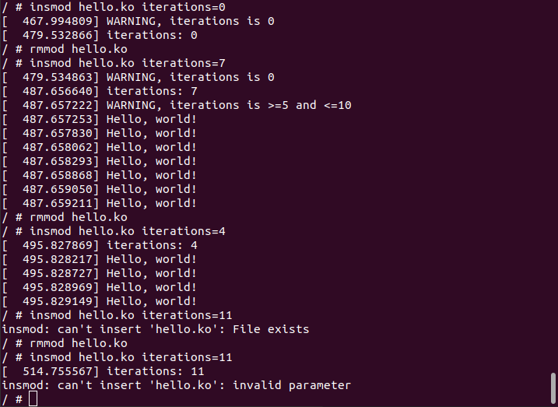
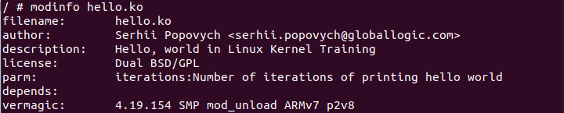
Рис.1 - Тестування з різними значеннями параметру

Рис.2 – значення, що повертає команда modinfo

ADVANCED
Лістинг

hello1.c

#include <linux/init.h>
#include <linux/module.h>
#include <linux/printk.h>
#include <hello1.h>

MODULE_AUTHOR("Pavlovets");
MODULE_DESCRIPTION("Hello1 component");
MODULE_LICENSE("Dual BSD/GPL");

static void print_hello(uint n){
uint i = 0;
for(i=0;i<n;i++){
pr_info("Hello world\n");
}
}
EXPORT_SYMBOL(print_hello);

static int __init hello1_init(void)
{
pr_info("Hello1_init started");
return 0;
}

static void __exit hello1_exit(void)
{
}

module_init(hello1_init);
module_exit(hello1_exit);

hello2.c

#include <linux/init.h>
#include <linux/module.h>
#include <linux/printk.h>
#include <hello1.h>

MODULE_AUTHOR("Pavlovets");
MODULE_DESCRIPTION("Hello, world in Linux Kernel Training");
MODULE_LICENSE("Dual BSD/GPL");

static uint iterations = 1;
module_param(iterations, uint, S_IRUGO);
MODULE_PARM_DESC(iterations, "Number of iterations of printing hello world");

static int __init initter(void)
{
uint i = 0;

printk(KERN_INFO "iterations: %d\n", iterations);

if(iterations == 0) {
pr_warning(KERN_WARNING "WARNING, iterations is 0");
}else if(iterations >=5 && iterations <= 10) {
pr_warning(KERN_WARNING "WARNING, iterations is >=5 and <=10");
} else if(iterations > 10) {
pr_err(KERN_ERR "ERROR, iterations is >10");
return -EINVAL;
}
print_hello(iterations);
return 0;
}

static void __exit exitter(void)
{
/* Do nothing here right now */
}

module_init(initter);
module_exit(exitter);

hello.h

static void print_hello(uint n);

Kbuild

# kbuild part of makefile
obj-m := hello1.o hello2.o
ccflags-y := -I$(PWD)/inc
Скріншоти

